**Quantifying habitat change of the red panda (*Ailurus Fulgens*)**

Dissertation Plan

Cameron Cosgrove s1427163

Research Motivation

Habitat change and fragmentation represent primary drivers of ecosystem change1. Whilst the impact of these factors on biodiversity can be mixed2, the impact on individual species can be more clearly predicted3. A reduction in the range and connectivity within a species habitat can reduce the genetic viability of a population and decrease the carrying capacity of the habitat. Sufficient habitat loss frequently leads to the collapse and extinction of local populations1. Human activity has resulted in a dramatic change to habitat configuration and land cover globally, altering the population dynamics of many species4. The large impact anthropogenic process area having on wildlife populations have resulted in a number of ‘winner’ and ‘loser’ species across taxa. Certain ecological and life history traits make species more susceptible to population decreases due to anthropogenic processes5. The negative impacts of habitat fragmentation are most pronounced for arboreal mammals and species with low dispersal capabilities1,3. Quantifying the extent and location of habitat change within a species range is key for predicting population responses6.

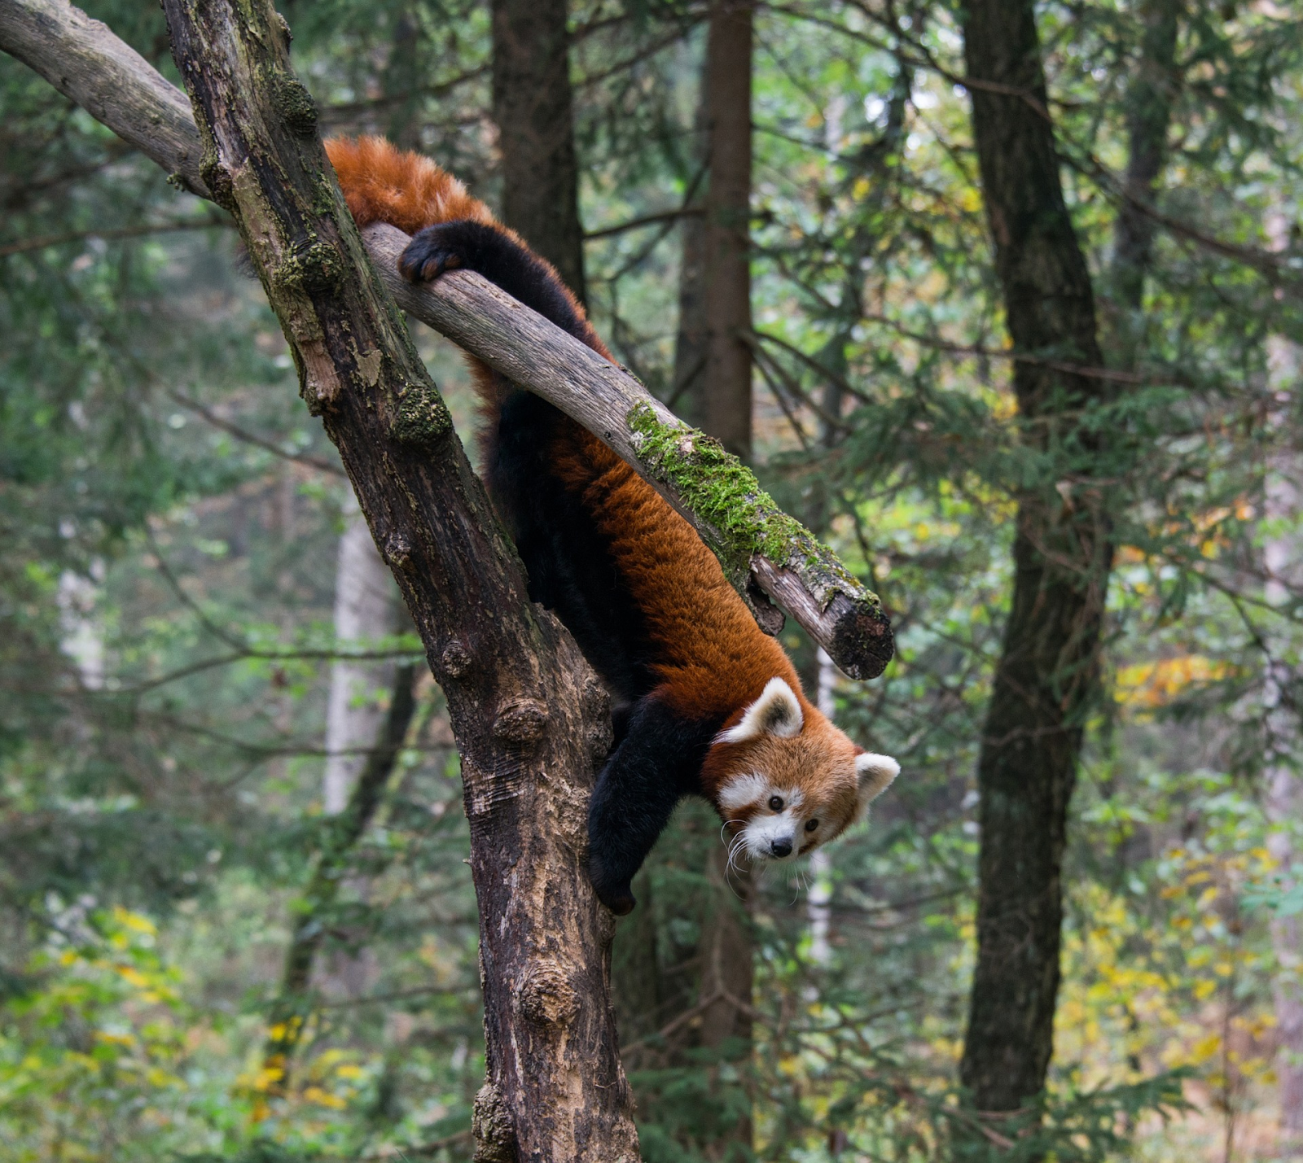The red panda (*Ailurus Fulgens*) is found on the southern slopes of the Himalayas and occupies bamboo mixed forest between 2000-4000 meters elevation7. An estimated 2,500 - 10,000 individuals remain in the wild and the species is classified as Endangered by the IUCN8. As an arboreal mammal with low dispersal capabilities (~30km in its lifetime) and a long, thin, linear range, it is particularly susceptible to the negative effects of habitat fragmentation1. Rapid human expansion across parts of its range has raised significant concern over the future and viability of the panda population. Human driven habitat loss has been consistently ranked as the largest threat facing the species, yet no assessment of the location and extent of loss has been conducted. There is sparse data on occurrences and population trends for red pandas4. However, their narrowly defined niche of intact high-altitude forest makes a remote sensing assessment of habitat change possible. By assuming any forest cover within the predicted range of the red panda represents its habitat, a reasonable quantification of habitat change can be conducted. Quantifying the location and extent of habitat change is a key priority in understanding the threats facing red pandas and informing conservation efforts.

**Figure 1: The red panda (*Ailurus Fulgens*) in typical habitat. Photo credit: The Red Panda Network.**

A raft of remote sensing products now exists that can quantify habitat change (Table 1 in methods). Pre-processed data products such as the Hansen Forest Cover9 and MODIS10 global land classification allow for rapid habitat analysis over large areas, without the time-consuming act of processing raw satellite imagery. Large spatial analyses, such as quantifying habitat loss across multiple countries, requires large processing power. The Google Earth Engine (GEE) provides a platform to conduct analysis such as this. The Hansen Forest Loss dataset is reliable for detecting large scale forest change chunks but may not pick up small agro-deforestation common in remote Himalayan areas11. However, combined with other Landsat and MODIS data products, it should indicate the areas experiencing moderate to pronounced habitat change. These datasets provide an appropriate tool to create a first conservative 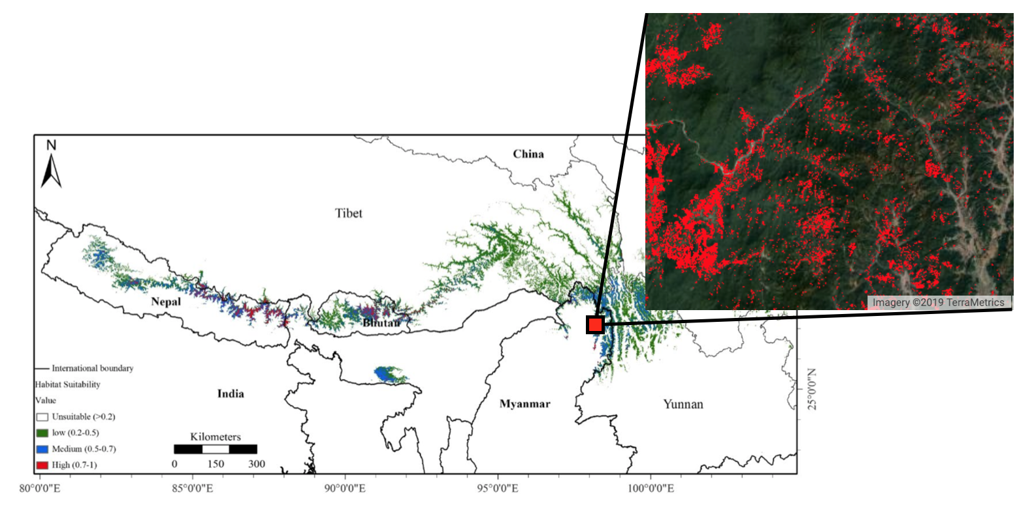estimate of recent habitat loss across the red panda’s range.

**Figure 2: Predicted red panda habitat (left) from Thapa *et al***7 **and an example of forest loss in a 10km2 area of Myanmar from 2000-2017** **(Marked by the red pixels in the right box).**

Objectives

I will use pre-existing remote sensing data products to quantify the habitat change throughout the predicted range of the red panda from 2000 to 2017. I will identify the extent and rate of habitat change and, time willing, explore the drivers of this change. I will also explore if there are any isolated red panda habitats, cut off from the larger population. Hot spots of habitat loss and other useful conservation outcomes will also be identified. I intend to disseminate my finding to relevant conservation agencies who I hope can use my project outputs to inform transboundary conservation efforts for red pandas.

Research Questions and Hypotheses

**RQ1: How is the area of red panda habitat changing?**

**H1:** The area of red panda habitat will have decreased from 2000 to 2017.

**H10:** There is no significant difference in the area of red panda habitat from 2000 to 2017.

**H2:** The magnitude and rate of red panda habitat loss will be significantly different in different parts of its range.

**H20:** The magnitude and rate of red panda habitat loss will not be significantly different in different parts of its range.

**RQ2: How connected is red panda habitat?**

**H1:** More than 5% of suitable red panda habitat is isolated from the core connected habitat. **H10:** No area of suitable red panda habitat is isolated from the core connected habitat.

**H2:** The area of connected forest has decreased between 2000 and 2017 in red panda habitat.

**H20:** The area of connected forest has not changed between 2000 and 2017 in red panda habitat.

**RQ3: What factors are driving habitat change? \***

**H1:** Increase in urban land use will correlate with increased red panda habitat loss.

**H10:** Increase in urban land use will not be correlated with increased red panda habitat loss.

**H2:** Where red panda habitat loss has occurred, the new land cover type will be either urban, agricultural, or grassland.

**H20:** Where red panda habitat loss has occurred, there is no pattern in the replacement land cover type.

**\***RQ3 will only be tested if RQ1 and RQ2 are sufficiently answered by week 4 of the project.

Predictions

I expect to see pronounced forest loss around urban areas and that the rates of forest loss are increasing in regions with expanding urban areas. Due to the remote nature of the majority of the habitat, I expect to see little habitat change at the more inaccessible high elevations. I expect protected areas to show less forest loss than unprotected areas. Due to different population densities, I expect to see differences in the extent and rate of forest loss in different countries, with Nepal and Tibet showing the least forest loss.

I expect Red Panda habitat to become more fragmented overtime due to deforestation. However, this signal might be small as most fragmentation may have occurred pre-2000 so cannot be detected by the datasets (all datasets I am using start in 2000). Because of this, I expect large areas of Red Panda habitat to be already isolated from the core habitat.

I expect areas of large forest loss to be replaced by land cover associated with agriculture or grazing. Deforestation for farming has been identified as a large cause of habitat change in the Himalayas12.

Proposed Methods

I will be utilizing the Google Earth Engine, a global spatial analysis platform, to explore a range of datasets (Table 1) inside predicted Red Panda habitat.

I plan to use a Red Panda distribution shapefile created by Thapa *et al*7. I have contacted the authors to see if they are willing to share this with me. If I cannot get access to this shapefile I will create my own based on their distribution model.

Forest loss can be quantified within a shapefile so estimates of habitat loss are easy to work out for any determined area. Across the predicted red panda range, I will calculate forest loss within different countries, protected areas, and within different MODIS land classes. The Hansen dataset also contains the yearly forest loss from 2000-2017 so I will be able to explore the rates of forest loss too.

|  |  |  |
| --- | --- | --- |
| Dataset | Description | When will it be used? |
| Hansen Forest Loss8 | 30 m x 30 m resolution, showing the global % treecover in 2000 and where forest has been lost and gained per year from 2000 – 2017. | RQ1 and RQ2 |
| MODIS Land Cover9 | 500m x 500 m resolution, showing the different classes of land cover globally, every year from 2000 – 2017 | RQ1 and RQ3 |
| World dataset of Protected Areas12 | A suit of polygon shape files detailing every recorded protected area around the world. | RQ1 |
| MaxEnt red panda distribution model6 | A shapefile output of a MaxEnt distribution model created for red pandas by Thapa *et al.* The shapefile shows where high, medium, and low red panda habitat suitability is. | RQ1, RQ2, RQ3 |

**Table 1: Datasets to be used in my analysis.**

Habitat fragmentation and connectivity will be explored a number of ways. The area of connected forest pixels can be calculated in the GEE and contiguous patches of habitat can be identified. The distance between patches can also be calculated in the GEE. By using the maximum recorded dispersal by a red panda (50km) I can define a dispersal buffer around habitat patches. Patches of suitable habitat that are beyond the dispersal buffer can be assumed to be isolated.

Land cover can be explored using the MODIS global classification dataset. The area of different classified pixels can be measured over time. Remotely sensed land cover is a good proxy for land use and can be used to explore the anthropogenic uses of a landscape13. This will primarily be used to measure the urban and agricultural land cover change in red panda habitat.

Example calculation scripts can be found at <https://github.com/CameronCosgrove/Red-Panda-Hub>

Statistical treatment

Linear mixed models will be used to test differences in forest loss between areas and over time. The statistical analysis will be conducted in R14 using the lme415 mixed effect model package.

The estimated omission and commission error of the MODIS and Hansen classification are stated in the data set documentation and will be incorporated into the statistical analysis.

Risk mitigation

The largest threat to my project will be data loss. To account for this, I am using Github to version control all of my work online, and I will back up all local documents on my external hard drive. I have built in extra time into my work plan to deal with any issues if they arise.

If my proposed analysis requires more work than I expect, I have designed my workflow to address the core questions first. I will hopefully have my main results after week three of the project. If this doesn’t go to plan then I have time to re-evaluate my project before submission.

Project management

Before the official start on the 24th of February I will have:

* Pre-registered my project at https://cos.io/prereg/,
* Tested out every algorithm and GEE tool I will use in answering my hypothesis,
* Created a data frame template to store the results of my analysis in.

The project will be tracked on Github and my supervisor will be able to easily monitor my progress. Fortnightly meetings will be organised with my supervisor and co-supervisor to discuss my targets and any issues I encounter.

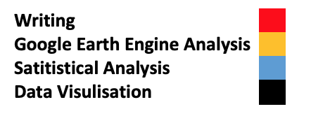Proposed workflow

References

1. Lino A, Fonseca C, Rojas D, Fischer E, Ramos Pereira MJ. A meta-analysis of the effects of habitat loss and fragmentation on genetic diversity in mammals. Mamm Biol [Internet]. 2018 Sep 17 [cited 2019 Jan 22]; Available from: http://www.sciencedirect.com/science/article/pii/S1616504718300090

2. Fletcher RJ, Didham RK, Banks-Leite C, Barlow J, Ewers RM, Rosindell J, et al. Is habitat fragmentation good for biodiversity? Biol Conserv. 2018 Oct 1;226:9–15.

3. Tucker MA, Böhning-Gaese K, Fagan WF, Fryxell JM, Moorter BV, Alberts SC, et al. Moving in the Anthropocene: Global reductions in terrestrial mammalian movements. Science. 2018 Jan 26;359(6374):466–9.

4. Buchanan GM, Butchart SHM, Dutson G, Pilgrim JD, Steininger MK, Bishop KD, et al. Using remote sensing to inform conservation status assessment: Estimates of recent deforestation rates on New Britain and the impacts upon endemic birds. Biol Conserv. 2008 Jan 1;141(1):56–66.

5. Fischer J, Lindenmayer DB. Landscape modification and habitat fragmentation: a synthesis. Glob Ecol Biogeogr. 2007;16(3):265–80.

6. Donnelly JP, Tack JD, Doherty KE, Naugle DE, Allred BW, Dreitz VJ. Extending Conifer Removal and Landscape Protection Strategies from Sage-grouse to Songbirds, a Range-Wide Assessment. Rangel Ecol Manag. 2017 Jan 1;70(1):95–105.

7. Thapa A, Wu R, Hu Y, Nie Y, Singh PB, Khatiwada JR, et al. Predicting the potential distribution of the endangered red panda across its entire range using MaxEnt modeling. Ecol Evol. 2018 Nov 1;8(21):10542–54.

8. Bista M, Panthi S, Weiskopf SR. Habitat overlap between Asiatic black bear Ursus thibetanus and red panda Ailurus fulgens in Himalaya. Yue B-S, editor. PLOS ONE. 2018 Sep 6;13(9):e0203697.

9. Hansen MC, Potapov PV, Moore R, Hancher M, Turubanova SA, Tyukavina A, et al. High-Resolution Global Maps of 21st-Century Forest Cover Change. Science. 2013 Nov 15;342(6160):850–3.

10. M. Friedl DS-M. MCD12Q1 MODIS/Terra+Aqua Land Cover Type Yearly L3 Global 500m SIN Grid V006 [Internet]. NASA EOSDIS Land Processes DAAC; 2015 [cited 2019 Jan 31]. Available from: https://lpdaac.usgs.gov/node/1260

11. UMD_accuracy_assessment_website_report_Final.pdf [Internet]. [cited 2019 Jan 28]. Available from: https://ecometrica.com/wp-content/uploads/2015/08/UMD_accuracy_assessment_website_report_Final.pdf

12. Chettri N, Shakya B, Thapa R, Sharma E. Status of a protected area system in the Hindu Kush-Himalayas: An analysis of PA coverage. Int J Biodivers Sci Manag. 2008 Sep 1;4(3):164–78.

13. Schneider A, Friedl MA, Potere D. A new map of global urban extent from MODIS satellite data. Environ Res Lett. 2009 Dec 1;4(4):044003.

14. R Core Team (2019). R: A language and environment for statistical computing. R Foundation for Statistical Computing, Vienna, Austria. ISBN 3-900051-07-0, URL http://www.R-project.org/. 2019.

15. lme4.pdf [Internet]. [cited 2019 Jan 31]. Available from: https://cran.r-project.org/web/packages/lme4/lme4.pdf